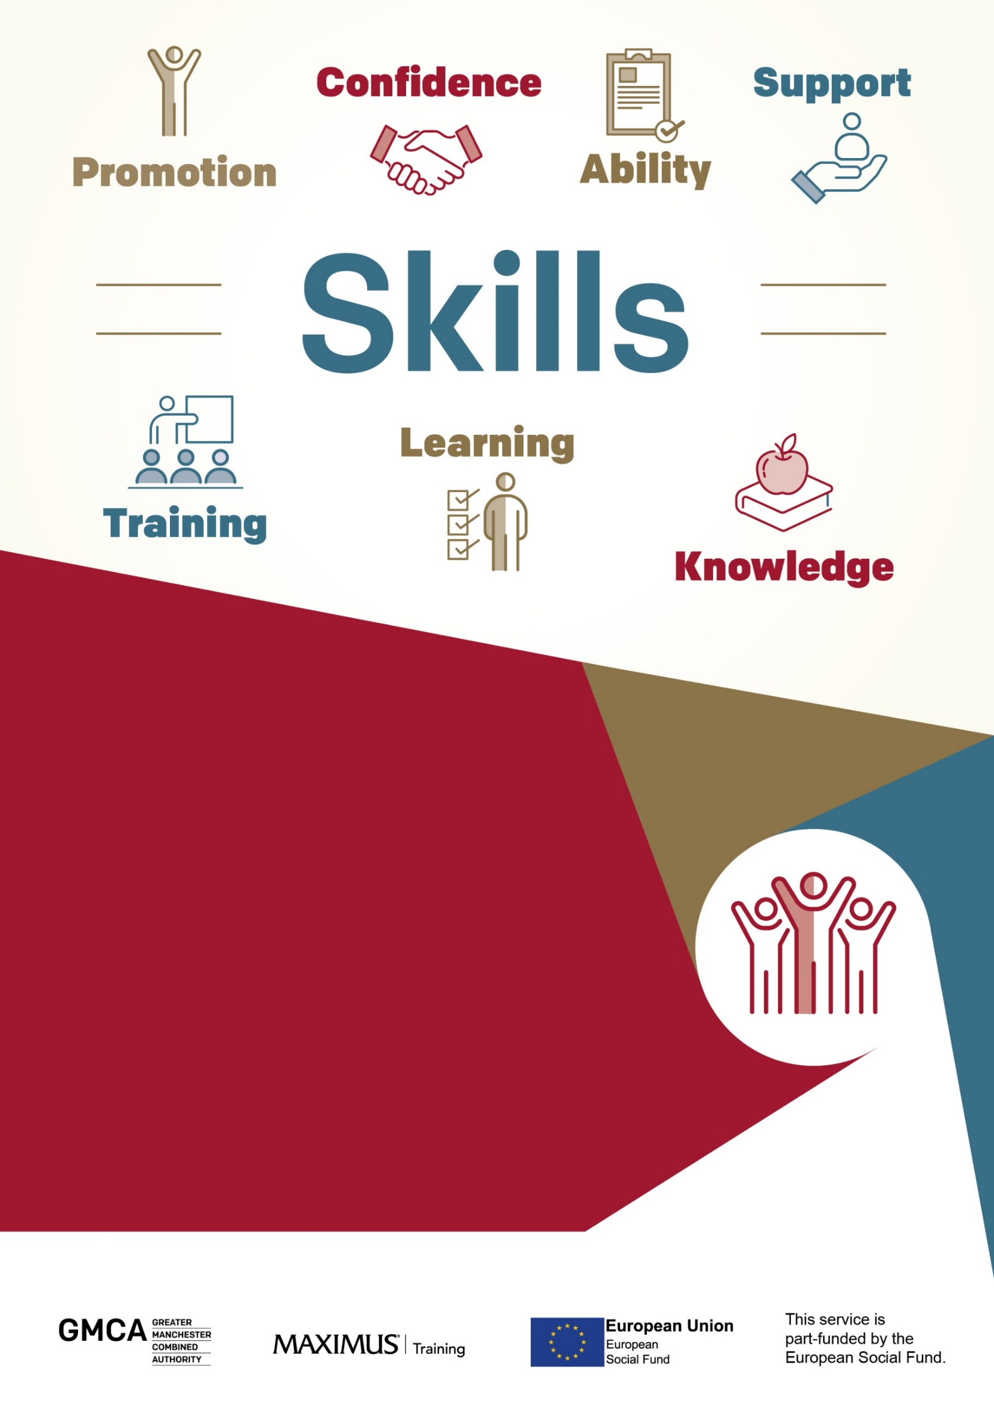

AEB 2020 Upcoming Courses

Please contact Jacqueline Chantler for further information

Phone: 07778 138750
Email: jchantler@maximus-training.com

COURSES | COURSE START DATE | TIME | LOCATION
Customer Service with Employability | April 2020  Over 10 days | 9.30 am - 2:30pm | Online
Wellbeing programme | 14 April 2020  Over 16 days | 9.30am - 2:30pm | Online
Maths | April 2020  Over 13 days  Open start date | 9.30 am -2:30pm | Online
English | April 2020  Over 13 days  Open start date | 9.30 am - 2.30pm | Online
ESOL –E1-E2- E3 | 20 April 2020  Over 20 days | 09:30am- 4:30pm | Online
NCFE Level 1 Award Managing Your Money | April 2020  Open start date | 5 days | Online
NCFE Level 1 Certificate Digital Skills | April 2020  Open start date | 15 days | Online
NCFE Level 2 Certificate Digital Skills for Work | April 2020  Open start date | 15 days | Online
NCFE Level 2 Certificate Equality and Diversity | April 2020  Open start date | 15 days | Online
NCFE Level 2 Certificate Understanding Data Protection and Data Security | April 2020  Open start date | 15 days | Online
NCFE Level 2 Certificate Understanding Nutrition and Health | April 2020  Open start date | 15 days | Online
NCFE Level 2 Certificate Understanding Retail Operations | April 2020  Open start date | 15 days | Online
Cache Level 2 Certificate Understanding Safeguarding and Prevent | April 2020  Open start date | 15 days | Online
Please note: A start date cannot be given until the learner has completed their initial assessment.
Learners will need proof of ID, Address and benefit verification to start a programme.

To be eligible all learners must be:
- 19+
- Unemployed
- Not in Education or Training
- A Greater Manchester resident

All learners who complete the programme will have access to any of the vacancies available with our employers.

About our courses:
All Courses are fully funded

ESOL
This course will provide the learner with the essential language skills needed to be able to properly communicate in English. Covering areas such as grammar and punctuation; writing and reading; and speaking and listening. Learners will develop a better understanding of the English language with the aim of progressing learners from Entry 3, to Entry 2, to Entry 1.

Customer Service
The Awards/Certificates for Introduction to Customer Service qualifications cover the basic elements of how to deliver an excellent customer experience, ranging from answering the telephone to applying legislation. The course will suit the learner if they are looking to work in the customer service industry but currently have no knowledge and experience. At this level they will develop their customer service knowledge.

Wellbeing and Employability
The course is designed to help learners to develop personal resilience and well-being, and develop coping strategies. The course will equip learners to develop an awareness of mental health, stress and stress management and the impact of a healthy lifestyle. In terms of employability learners will develop confidence in dealing with problems, decision making and self-assessment.

English/Maths (Functional Skills)
Good literacy and numeracy skills are essential for everyday life. These qualifications are designed to enable students to develop confidence and fluency in Maths and English. They equip learners with the practical skills to get the most out of education, work and everyday life and to help them function more confidently, effectively and independently.

Managing Your Money
Taking the time to manage money better can really pay off. This course is designed to give learners practical knowledge of how to manage money. It covers financial products and services; personal pensions; insurance; borrowing money; savings; managing personal finances and credit scoring.

Digital Skills
In a world where our daily life requires more digital knowledge for normal tasks, it has become increasingly important to have the right skills in order to use computers and other technological devices. This course is aimed to help support development with digital literacy skills, encouraging progression into roles where digital literacy is required. Learners will achieve a nationally recognised Level 1 qualification from NCFE; acquire evidence of competency to employers and increase work productivity; and develop knowledge and competency of digital literacy skills.

Digital Skills for Work
This Level 2 course is designed to equip learners with the fundamentals of the use of digital skills in the workplace: using and managing information; keeping yourself and others safe when using digital devices; communicating and collaborating online; and digital career development.

Equality and Diversity
This Level 2 course is designed for learners to understand Equality and diversity in the context of society; the community; and the workplace. It equips learners with knowledge about Equality legislation and the duties set down in law for all employers and service providers to provide equality of opportunity, the types of discrimination, and how these may present; and the importance of creating a fairer and equal society for all.

Understanding Data Protection and Data Security
In light of the General Data Protection Regulations (GDPR) that came into force in 2018 this course is designed to give learners an understanding of current data protection legislation and organisational procedures concerning data

Understanding Nutrition and Health
This Level 2 online course supports optimal health and well-being which is becoming increasingly important in modern lifestyles that are often stressful. Besides the external pressures that bring stress on the body there are internal influences that we can control such as what we eat that will have beneficial effects on the way our digestive, immune and nervous systems are functioning. The food we eat has a direct impact on our health. This course explores the principles of healthy eating and considers the nutritional needs of different individuals

Understanding Retail Operations
This course is designed to enable learners to gain an understanding good customer service. It covers the selling process and how to maximise the effectiveness of a retail business; understanding Health and Safety; consumer law and how to deal with customer queries and complaints in a retail environment; an understanding of handling customer payments and the control, receipt and storage of stock in a retail business.

Understanding Safeguarding and Prevent
This Level 2 course equips learners with the knowledge of their duties under ‘Prevent’ with the aim of giving learners an understanding of radicalisation, terrorism and safeguarding responsibilities to keep children and vulnerable adults safe from harm; and promote British Values.

